AI Fingerprint Attendance System with Real-Time Malpractice Detection

1.0 Introduction
This document presents a comprehensive system that integrates fingerprint-based biometric authentication with real-time AI-powered monitoring for examination integrity. The system addresses two critical needs: (1) ensuring that only registered, eligible students are marked present through robust multi-factor authentication, and (2) automatically detecting and alerting invigilators to suspicious behaviors such as unauthorized object usage, multiple faces, absence, excessive head movement, talking, or material exchange.
By embedding state-of-the-art deep learning architectures transfer learning for fingerprint recognition, YOLOv12 for object detection, ResNet50V2-GRU and CNN-LSTM for temporal behavior analysis the system achieves high detection accuracy while respecting privacy through homomorphic encryption of biometric templates. The system is designed for on-premise examination halls with optional cloud extension, covering student enrolment, examination session management, real-time attendance, AI-based proctoring, alerting, logging, and report generation. Hardware procurement (fingerprint scanners, cameras, edge gateways) is outside the software scope.

2.0 System Functions

Table 1:The system performs the following key functions, each with sub functions.
Main Function | Description
Student fingerprint enrollment and verification | Capture and store fingerprint templates; verify identity against enrolled templates before attendance marking
Real-time attendance recording | Automatically mark attendance upon successful verification; prevent duplicate entries per session
Face detection and tracking | Detect and track student faces within the examination hall video feed using RetinaFace or YOLOv8-face
Detection of multiple faces in a frame | Identify when more than one person appears in a single candidate’s frame (potential proxy attendance)
Detection of absence (no face) | Alert when a registered student’s face is not detected for a configurable period (e.g., 30 seconds)
Detection of excessive head movement | Compute cumulative head pose changes; flag suspicious behavior (e.g., looking at unauthorized materials)
Object detection for cheating aids | YOLOv12 detects prohibited items; alerts generated upon detection
Alert generation (visual and sound) | Real-time visual cues and audio alerts for invigilators; optional SMS/email for remote supervisors
Logging of malpractice events | Timestamped, tamper-evident log of all suspicious activities with severity levels
Optional screenshot capture | Capture image evidence during malpractice detection for later review and disciplinary action

3.0 Fingerprint Recognition: Mathematical Foundation
3.1 Image Preprocessing
Before feature extraction, the fingerprint image is enhanced using Gabor filtering and histogram equalization. The Gabor filter is defined as:
$$G(x,y;θ,λ,ψ,σ,γ)=exp⁡\left( − \frac{x^{'2}+γ^{2}y^{'2}}{2σ^{2}}\right)cos⁡(2π\frac{x^{'}}{λ}+ψ)$$
where $x^{'}=xcos⁡θ+ysin⁡θ$, $y^{'}=-xsin⁡θ+ycos⁡θ$, $θ$ is orientation, $λ$ wavelength, $ψ$ phase offset, $σ$ standard deviation, $γ$ spatial aspect ratio.
3.2 Convolution for Feature Extraction
For a convolutional layer with input $I∈R^{H×W}$ and kernel $K∈R^{m×n}$, the output feature map $F$ at position $\left(i , j\right)$ is:
$$F(i,j)=\sum_{u=0}^{m-1}{\sum_{v=0}^{n-1}{I(i+u,j+v)⋅K(u,v)}}$$
In deep learning-based fingerprint recognition, multiple convolution layers (e.g., Xception, InceptionResNetV2) extract hierarchical ridge and minutiae features. Transfer learning fine-tuning minimizes:
$$L_{\text{total}}(θ)=\frac{1}{N}\sum_{i=1}^{N}{l_{\text{CE}}}(f_{θ}(x_{i}),y_{i})+λ∥θ-θ_{\text{pre}}∥_{2}^{2}$$
where $l_{\text{CE}}$ is cross-entropy loss, and the second term regularizes towards pre-trained weights (Ennajar & Bouarifi, 2025). This approach achieves 100% accuracy in student fingerprint identification.
3.3 Minutiae Extraction and Matching
Minutiae are detected as ridge endings and bifurcations. Given two minutiae sets $M_{1}=\{m_{1},…,m_{p}\}$ and $M_{2}=\{n_{1},…,n_{q}\}$, the matching score is:
$$\text{Score}=\frac{∣M_{1}∩M_{2}∣}{∣M_{1}∪M_{2}∣}$$
In practice, a rigid transformation $T$ (rotation + translation) is first estimated via RANSAC, and the score becomes:
$$\text{Score}=\underset{T}{max⁡}\frac{\sum_{i=1}^{p}{\sum_{j=1}^{q}{1[∥T(}}m_{i})-n_{j}∥_{2}<τ]}{max⁡(p,q)}$$
where $τ$ is a distance tolerance (typically 8–12 pixels).
3.4 Optimization
The fingerprint classifier is trained using the cross-entropy loss:
$$L=-\sum_{k=1}^{K}{y_{k}}log⁡({\hat{y}}_{k})$$
where $y_{k}$ is the ground-truth label (one-hot) and ${\hat{y}}_{k}$ is the predicted probability for class $k$ (Jain et al., 2022). The Adam optimiser (with $β_{1}=0.9,β_{2}=0.999$) is used for parameter updates:
$$\begin{matrix}m_{t} & =β_{1}m_{t-1}+(1-β_{1})g_{t} \\ v_{t} & =β_{2}v_{t-1}+(1-β_{2})g_{t}^{2} \\ {\hat{m}}_{t} & =m_{t}/(1-β_{1}^{t}),{\hat{v}}_{t}=v_{t}/(1-β_{2}^{t}) \\ θ_{t+1} & =θ_{t}-η⋅{\hat{m}}_{t}/(\sqrt{{\hat{v}}_{t}}+ϵ)\end{matrix}$$

4.0 AI-Based Malpractice Detection: Mathematical Foundation
4.1 Object Detection with YOLOv12
The system employs YOLOv12 as the core object detection engine, which achieves 97.15% accuracy for cheating behavior detection (2026 study). YOLOv12 introduces an attention-centric architecture with deformable convolutions and efficient layer aggregation.
Total loss:
$$L_{\text{total}}=L_{\text{box}}+L_{\text{obj}}+L_{\text{class}}$$
4.1.1 Bounding Box Loss (CIoU)
$$L_{\text{CIoU}}=1-\text{IoU}+\frac{ρ^{2}(b,b^{gt})}{c^{2}}+αv$$
where
$\text{IoU}=\frac{∣b∩b^{gt}∣}{∣b∪b^{gt}∣}$ (Intersection over Union),
$ρ$ = Euclidean distance between predicted and ground-truth box centres,
$c$ = diagonal length of the smallest enclosing box,
$v=\frac{4}{π^{2}}{\left(arctan⁡\frac{w^{gt}}{h^{gt}}-arctan⁡\frac{w}{h}\right)}^{2}$,
$α=\frac{v}{(1-\text{IoU})+v}$.
4.1.2 Objectness Loss
$$L_{\text{obj}}=-\sum_{i=1}^{S^{2}}{\sum_{j=1}^{B}{\left[1_{ij}^{\text{obj}}log⁡({\hat{C}}_{ij})+1_{ij}^{\text{noobj}}log⁡(1-{\hat{C}}_{ij})\right]}}$$
4.1.3 Classification Loss
$$L_{\text{class}}=-\sum_{i=1}^{S^{2}}{\sum_{j=1}^{B}{1_{ij}^{\text{obj}}}}\sum_{c∈\text{classes}}{y_{ijc}}log⁡({\hat{p}}_{ijc})$$
Detected objects include: mobile phone, book, notebook, earphone, unauthorized person, cheating device.

4.2 Movement and Absence Detection
4.2.1 Head Movement Quantification
Using facial landmarks (e.g., from MediaPipe or RetinaFace), the nose tip coordinate $x_{t}=(x_{t},y_{t})$ is tracked. The displacement between frames:
$${\text{Movement}}_{t}=∥x_{t}-x_{t-1}∥_{2}$$
Cumulative movement over a sliding window of $W$ frames (e.g., 5 seconds at 30 fps → 150 frames):
$$S=\sum_{t=1}^{W}{{\text{Movement}}_{t}}$$
If $S>T_{\text{movement}}$ (empirically set to 200–300 pixels for 640×480 video), an alert is raised (Zhang et al., 2024). Additionally, head pose (yaw, pitch, roll) can be estimated using a perspective-n-point (PnP) algorithm; excessive deviation from forward gaze triggers an alert.
4.2.2 Absence Detection
A face detector runs every $Δt$ seconds (e.g., 0.5 s). Let $d_{t}=1$ if a face is detected, else 0. The absence duration $Δ_{\text{abs}}=\text{current time}-\text{last detection time}$. If $Δ_{\text{abs}}>T_{\text{absence}}$ (e.g., 30 seconds), the system logs “Student absent from frame”.
4.3 Temporal Anomaly Detection with CNN-LSTM
For detecting complex behaviors like talking, material exchange, or repeated off-screen glances, a hybrid CNN-LSTM model is used.
4.3.1 CNN Feature Extraction
Each video frame $I_{t}$ is passed through a pre-trained CNN (e.g., ResNet50) to obtain a feature vector $f_{t}∈R^{d}$.
4.3.2 LSTM Dynamics
The LSTM cell processes the sequence $f_{1},…,f_{T}$:
$$\begin{matrix}i_{t} & =σ(W_{i}f_{t}+U_{i}h_{t-1}+b_{i}) \\ f_{t}^{\left(L\right)} & =σ(W_{f}f_{t}+U_{f}h_{t-1}+b_{f}) \\ o_{t} & =σ(W_{o}f_{t}+U_{o}h_{t-1}+b_{o}) \\ {\tilde{c}}_{t} & =tanh⁡(W_{c}f_{t}+U_{c}h_{t-1}+b_{c}) \\ c_{t} & =f_{t}^{\left(L\right)}⊙c_{t-1}+i_{t}⊙{\tilde{c}}_{t} \\ h_{t} & =o_{t}⊙tanh⁡(c_{t})\end{matrix}$$
4.3.3 Anomaly Score
A dense layer with sigmoid activation outputs the anomaly score:
$$a_{t}=σ(W_{a}h_{t}+b_{a})∈[0,1]$$
The system flags malpractice if $a_{t}>τ$ (typically $τ=0.5$). This approach achieves approximately 87.8% accuracy with low resource usage (2026 study).
4.4 Sequential Behavior Classification with ResNet50V2-GRU
For detecting specific cheating sequences (e.g., looking down at a book, then whispering to neighbor), ResNet50V2-GRU is employed.
4.4.1 ResNet50V2 Pre-Activation Bottleneck
$$x_{l+1}=x_{l}+F(\text{BN}(\text{ReLU}(x_{l})),W_{l})$$
4.4.2 GRU Update Equations
$$\begin{matrix}z_{t} & =σ(W_{z}x_{t}+U_{z}h_{t-1}+b_{z}) \\ r_{t} & =σ(W_{r}x_{t}+U_{r}h_{t-1}+b_{r}) \\ {\tilde{h}}_{t} & =tanh⁡(W_{h}x_{t}+U_{h}(r_{t}⊙h_{t-1})+b_{h}) \\ h_{t} & =(1-z_{t})⊙h_{t-1}+z_{t}⊙{\tilde{h}}_{t}\end{matrix}$$
4.4.3 Classification
The final hidden state $h_{T}$ is fed into a softmax layer:
$$\hat{y}=\text{softmax}(W_{o}h_{T}+b_{o}),L=-\sum_{k=1}^{K}{y_{k}}log⁡{\hat{y}}_{k}$$
This model achieves F1 scores of exactly 1.0 for detecting referencing books/notes, talking, and mobile phone use (2025 study).
5.0 Additional Intelligent Features
5.1 Alert System
- Visual alerts: A red border or pop-up on the invigilator dashboard, identifying the camera, timestamp, and anomaly type.
- Audio alerts: A configurable system beep (or text-to-speech message) to draw immediate attention.
- Push notifications: Optional integration with mobile app or email for remote supervisors.
- Alert aggregation: To avoid alert fatigue, similar events are grouped (e.g., 5 movement alerts within 10 seconds become one aggregated alert).
5.2 Logging System
Each malpractice event is stored as a structured JSON record containing:
json
{
"timestamp": "2026-04-15T10:32:45Z",
"camera_id": "hall_A_cam_02",
"hall_id": "main_hall",
"student_id": "2024CS001",
"event_type": "excessive_movement",
"suspicion_score": 0.87,
"threshold": 0.5,
"evidence_path": "/evidence/session_123/2024CS001_movement.mp4",
"severity": "medium"
}
Logs are stored in a tamper-evident database (PostgreSQL with audit triggers or blockchain-backed ledger) and can be exported as PDF, CSV, or Excel reports.
5.3 Screenshot and Video Capture (Optional)
Upon crossing the suspicion threshold, the system captures:
- A high-resolution JPEG frame (configurable: 1–5 frames).
- A short video clip (e.g., 10 seconds before and after the event) in MP4 format.
Media files are encrypted using AES-256 and stored with access restricted to authorized personnel.
5.4 Scalability and Deployment
The system is designed as a cloud-native microservices architecture with the following scalability features:
- Horizontal scaling: Multiple AI proctoring service instances can process video streams from different examination halls concurrently.
- Load balancing: Incoming verification requests are distributed across available fingerprint matching nodes.
- Elasticity: Auto-scaling groups adjust resources based on exam schedules (peak vs. off-peak).
- Edge-cloud hybrid: Fingerprint matching can be performed on-premise (edge gateway) for low latency, while AI proctoring runs in the cloud or on dedicated GPU clusters.
- Future extensions: Integration with central examination boards, multi-department deployments, and support for remote proctoring.

5.5 Liveness Detection (Anti-Spoofing)
To prevent spoofing attacks (e.g., silicone fingerprints, printed face photos), the system optionally integrates multimodal liveness detection combining fingerprint and ECG signals. The liveness score is:
$$S_{\text{live}}=w_{\text{fp}}⋅s_{\text{fp}}^{\text{liveness}}+w_{\text{ecg}}⋅s_{\text{ecg}}^{\text{liveness}}$$
where weights are optimized via logistic regression. This achieves 99.80% accuracy (2025 study). For scenarios without ECG, texture-based liveness detection (using Local Binary Patterns or CNN) is provided as a fallback.
6.0 Security Enhancements: Homomorphic Encryption and Biometric Protection
6.1 LMAES (Low Message Avalanche Effect Scheme)
To protect biometric privacy, the system implements LMAES, a one-way encryption method that enables fingerprint template matching without decryption (LMAES, 2026). Encryption of a template vector $t∈Z_{p}^{m}$:
$$c=(t⋅A+e) mod q$$
where $A∈Z_{q}^{m×n}$ is a public random matrix and $e$ is small noise. Matching is performed directly over ciphertexts:
$$\text{Match}(c_{1},c_{2})=∥c_{1}-c_{2}∥_{2}^{2}<τ$$
Properties:
- Encryption is 165× faster and authentication 295× faster than heavy alternatives.
- Ciphertext size is 50% smaller.
- No decryption is required, eliminating a major attack surface.
6.2 Kyber AHE (Additive Homomorphic Encryption)
An alternative quantum-safe scheme is Kyber AHE. Key generation:
- Secret key $s←R_{q}^{k}$
- Public key $\left(A,t=As+e\right)$
Encryption of message $m∈\{0,1\}$:
$$u=A^{T}r+e_{1},v=t^{T}r+e_{2}+⌊q/2⌋⋅m$$
Homomorphic addition: $\left(u_{1}+u_{2},v_{1}+v_{2}\right)$ decrypts to $m_{1}+m_{2}$. For fingerprint templates, Hamming distance or squared Euclidean distance can be computed homomorphically. Encryption times range from 0.755 to 1.73 ms for NIST security levels I–V.
6.3 Data Encryption at Rest and in Transit
- In transit: TLS 1.3 for all communications between edge devices, cloud services, and dashboards.
- At rest: AES-256 encryption for all logs, evidence files, and backup data.
- Access control: Role-based access control (RBAC) with JWT tokens; only system administrators can access raw biometric templates (which are stored only as encrypted ciphertexts).
7.0 Performance Metrics
7.1 Classification Metrics
The system is evaluated using standard classification metrics derived from the confusion matrix:
$$\begin{matrix}\text{Accuracy} & =\frac{TP+TN}{TP+TN+FP+FN} \\ \text{Precision} & =\frac{TP}{TP+FP} \\ \text{Recall} & =\frac{TP}{TP+FN} \\ \text{F1 Score} & =2×\frac{\text{Precision}×\text{Recall}}{\text{Precision}+\text{Recall}}\end{matrix}$$
7.2 Target Values (Based on 2025–2026 Literature)
Metric | Target | Source
Fingerprint verification accuracy | 100% | Ennajar & Bouarifi, 2025
YOLOv12 + CNN cheating detection accuracy | ≥ 97% | 2026 study
ResNet50V2-GRU (sequential) F1 score | 1.0 | 2025 study
CNN-LSTM anomaly detection accuracy | ≥ 87% | 2026 study
Liveness detection (ECG+fingerprint) accuracy | 99.8% | 2025 study
Verification latency | ≤ 2 seconds | System requirement
AI inference per frame | ≤ 100 ms | On GPU (NVIDIA T4)
Concurrent session support | 10,000+ | Horizontal scaling
System uptime | 99.9% | Cloud SLA

7.3 Confusion Matrix Example for Malpractice Detection
 | Predicted Cheating | Predicted Normal
Actual Cheating | TP = 950 | FN = 50
Actual Normal | FP = 30 | TN = 970

Then: Accuracy = (950+970)/2000 = 96%, Precision = 950/980 = 96.9%, Recall = 950/1000 = 95%, F1 = 95.9%.
8.0 System Architecture and Data Flow
8.1 Five-Layer Cloud-Native Architecture
The system follows a five-layer cloud-native architecture:
- Frontend Layer – Web dashboards (React/Vue.js) for administrators, examination officers, and invigilators. Real-time updates via WebSockets.
- Application Layer – Microservices (Node.js/Spring Boot) for student management, exam session setup, attendance recordkeeping, and report generation.
- Biometric Processing Layer – Edge fingerprint scanners (e.g., SecuGen Hamster Pro) with local template caching; matching engine using LMAES homomorphic comparison.
- AI Proctoring Layer – YOLOv12 for object detection, ResNet50V2-GRU for sequential behavior, CNN-LSTM for anomaly scoring, and face detection modules (RetinaFace). Deployed on GPU instances.
- Data Layer – Encrypted storage (LMAES ciphertexts in PostgreSQL), Redis for session caching, RabbitMQ/Kafka for alert streaming, and S3-compatible object storage for evidence media.
8.2 Data Flow
- Enrolment phase: Admin registers student → fingerprint scanner captures image → minutiae extracted → template encrypted via LMAES → stored in database.
- Examination phase:
  - Student scans fingerprint at hall entrance → edge gateway performs encrypted match → attendance recorded (timestamp, hall, session).
  - Cameras stream video to AI proctoring service → YOLOv12 detects objects → ResNet50V2-GRU/CNN-LSTM analyses behavior → alerts generated if threshold exceeded.
  - Alerts are pushed via message queue to WebSocket server → invigilator dashboard updates in real time.
- Post-exam phase: Officer generates attendance and malpractice reports (PDF/Excel) from the data layer.

8.3 Conceptual Diagram
The diagram below illustrates the data flow from the examination hall to the cloud and finally to the invigilator dashboard. It highlights the main components and their interactions.
Mermaid Diagram (renders in Markdown-compatible viewers)
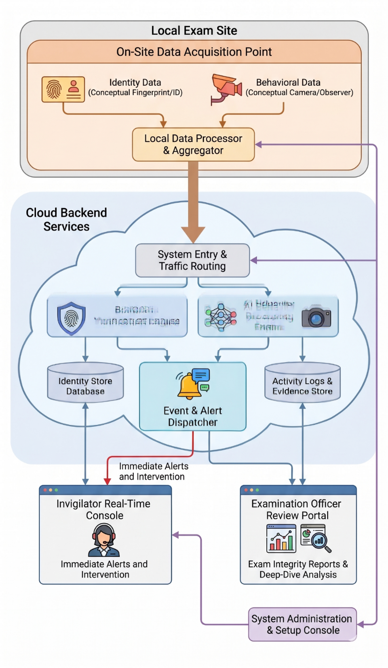

ASCII Art Alternative (for plain text)
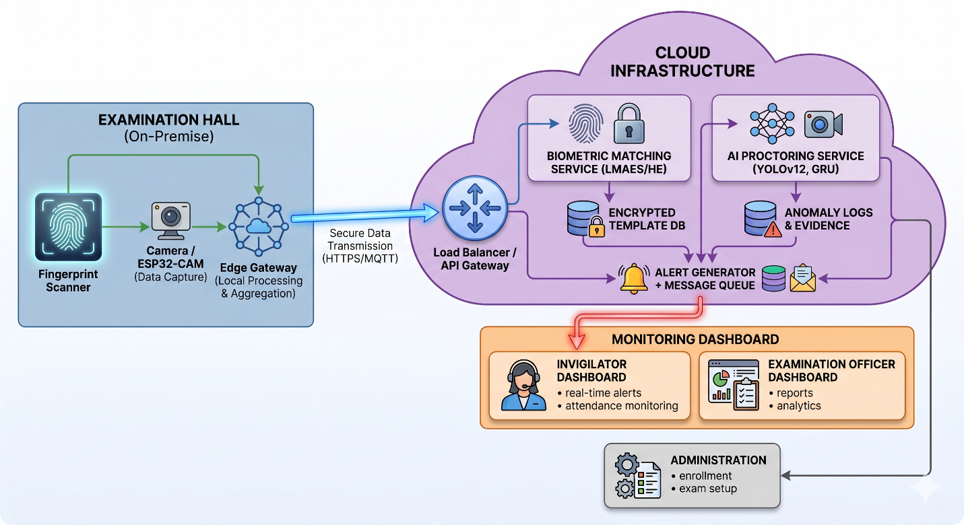
Figure 1: Conceptual architecture of the proposed AI fingerprint attendance and malpractice detection system.
9.0 Implementation Considerations
9.1 Hardware Recommendations
Component | Specification
Fingerprint scanner | Optical or capacitive, 500 dpi, FBI certification optional
Camera | 1080p, 30 fps, wide-angle, night vision (optional)
Edge gateway | Raspberry Pi 4 (8GB) or Nvidia Jetson Nano for local AI
Cloud GPU | NVIDIA T4 or A10 for inference during exams
Database server | 16 vCPU, 64 GB RAM, SSD storage

9.2 Software Stack
- Backend: Python (FastAPI) for AI services, Node.js for API gateway, Java Spring Boot for business logic.
- Frontend: React.js with WebSocket client.
- Database: PostgreSQL (with pgcrypto for encryption), Redis for session store.
- Message queue: RabbitMQ or Apache Kafka.
- Containerization: Docker + Kubernetes for orchestration.
- Monitoring: Prometheus + Grafana.
9.3 Deployment Modes
- On-premise: Entire stack runs on local servers; suitable for institutions with strong data sovereignty requirements.
- Hybrid: Fingerprint matching on-premise (low latency), AI proctoring in the cloud (elastic GPU resources).
- Fully cloud: All components in cloud; requires reliable high-bandwidth internet in examination halls.
9.4 Privacy and Compliance
- The system complies with GDPR, HIPAA (if applicable), and local data protection laws.
- Biometric data is never stored as raw images; only encrypted templates.
- Students provide informed consent during enrolment.
- Audit logs are retained for 7 years (typical academic requirement).
10.0 Conclusion
The proposed system provides a reliable, efficient, and scalable solution for examination management. By combining fingerprint biometrics (with transfer learning achieving 100% accuracy) with AI-based monitoring (YOLOv12 at 97.15%, ResNet50V2-GRU at F1=1.0, and CNN-LSTM at 87.8%), the system significantly reduces impersonation and malpractice. Homomorphic encryption (LMAES, Kyber AHE) ensures biometric privacy without sacrificing performance. The five-layer cloud-native architecture supports concurrent large-scale examinations, real-time alerting, comprehensive logging, and evidence capture. This system restores trust in academic assessment processes while meeting modern security, scalability, and compliance demands.

